Static website hosting in S3:
- Search S3 in AWS console
- Create Bucket -Public
- Give unique bucket name
- Create bucket
- Now click on the bucket:Upload-File&Folders-Add files-upload any image you want
- Click on the Object you will get Object URL
- This URL is visible only when policy is applied
- Apply Policy: Go to the Permissions in the bucket-bucket policy-edit-Paste below policy:
{
"Version": "2012-10-17",
"Statement": [
{
"Sid": "PublicReadGetObject",
"Effect": "Allow",
"Principal": "*",
"Action": "s3:GetObject",
"Resource": "arn:aws:s3:::mybucket-swatiwagh2121992/*"
}
]
}

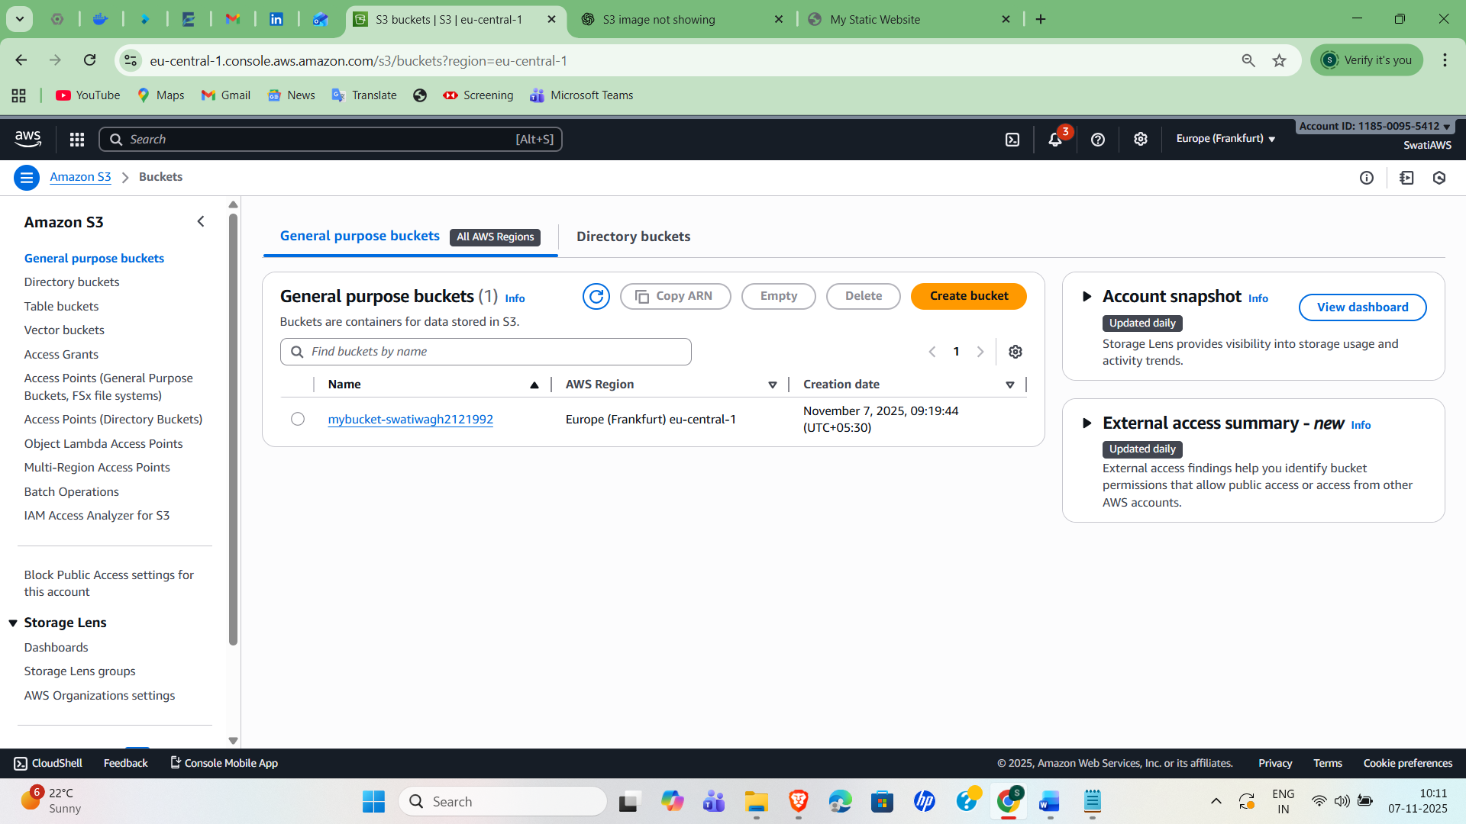

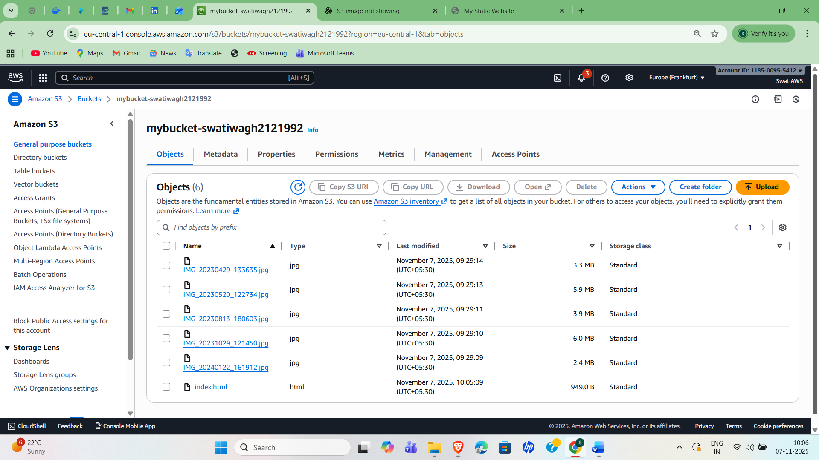

- Now we have to upload index.html file.
- Copy html code and save as index.html also in that code paste object URL of each image
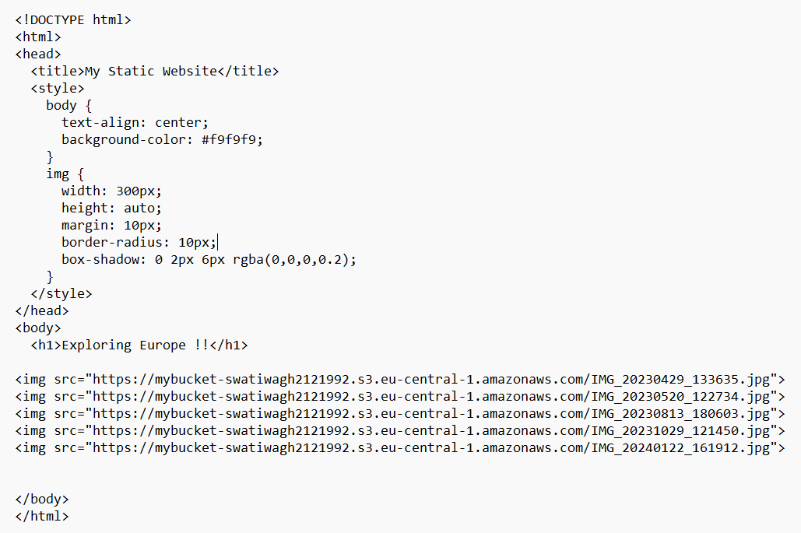
- Click bucket
- Upload-add files-upload index.html
- Properties – static website hosting – edit – enable -index.html-save
- Below you will get website URL at the end
